**ASSIGNMENT:-1**

**EECE:-212**

**NAME: Shaharehar Rahaman Anik**

**Level: 2**

**ID No: 201916058**

**Here are some mathematical problem are solved by MATLAB 2020a.according to the questions. The answers are given bellow**

**1. Write a program to calculate the approximated value of f(x) = (cos(x)) ^2 up to first 6 terms at x=1 (radian). Find out the absolute and relative errors. What happens to the error when number of terms is increased from 5 to 12?**

**Solution:**

Here the program to calculate the approximate value of f(x) = (cos(x)) ^2 up to first 6 terms at x=1 (radian).

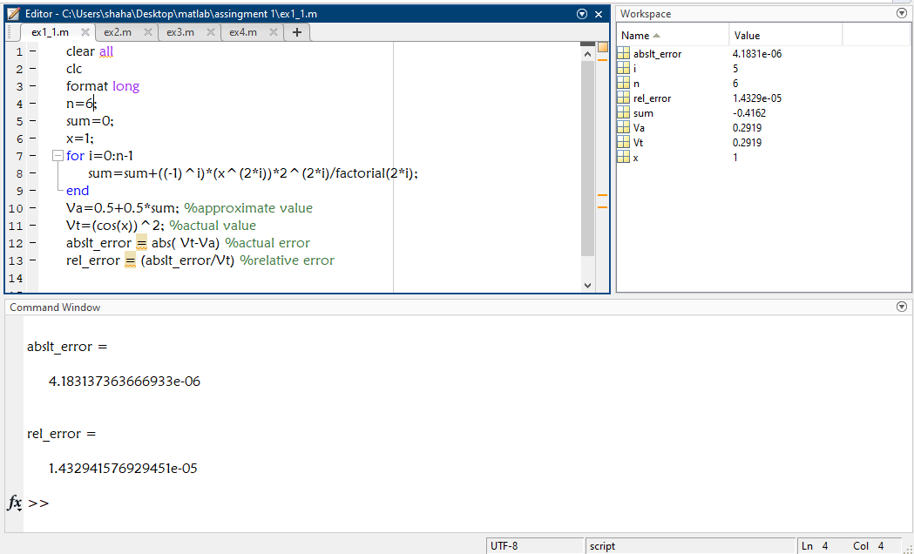

The absolute value is:

**4.183137363666933e-06**

And the relative value is:

**1.432941576929451e-05**

In the 2nd part of the que it’s wanted to know what happens to the error when number of terms is increased from 5 to 12?

We can solve it by using the terms 5 and 12. This programs are:

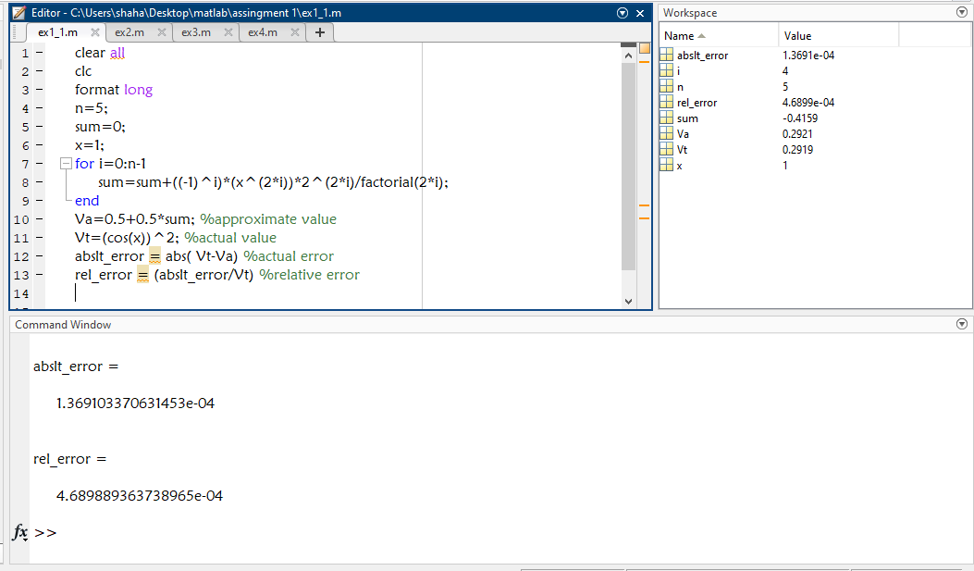

**And at terms 12:**

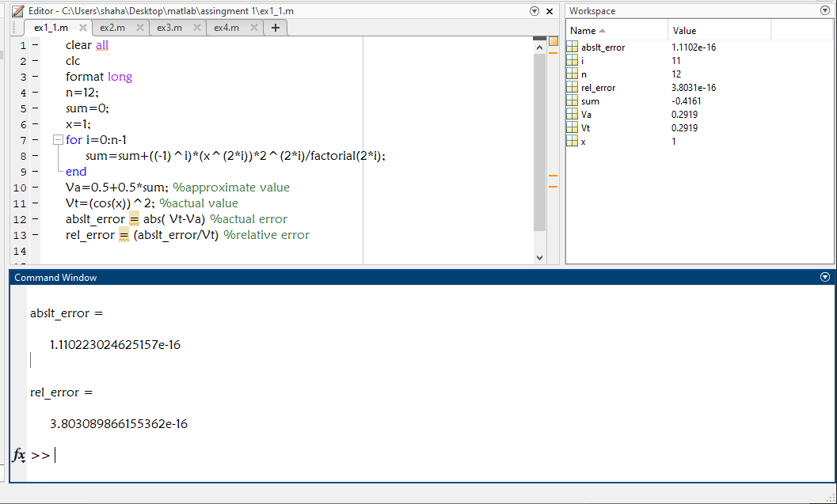

Here we can see that at terms **5**

The absolute value is:

**1.369103370631453e-04**

The relative value is:

**4.689889363738965e-04**

And at 12 terms

The absolute value is:

**1.110223024625157e-16**

The relative value is:

**3.803089866155362e-16**

**We can observe that the absolute value and relative value both of 12 terms are decreased from terms 5’s value**.

**2. Write a program to find out the number of terms N of the series f(x) = (cos(x)) ^2 in series expansion, such that their sum gives the value of f(x) correct to 12 decimal point. When 0<x<1. What is the value of error at this point?**

**Solution:**

Here is said to write a program to find out the number of terms N of the same series of Que. 1. As the sum gives the value of the function to 12 decimal point. Now the program is given bellow:

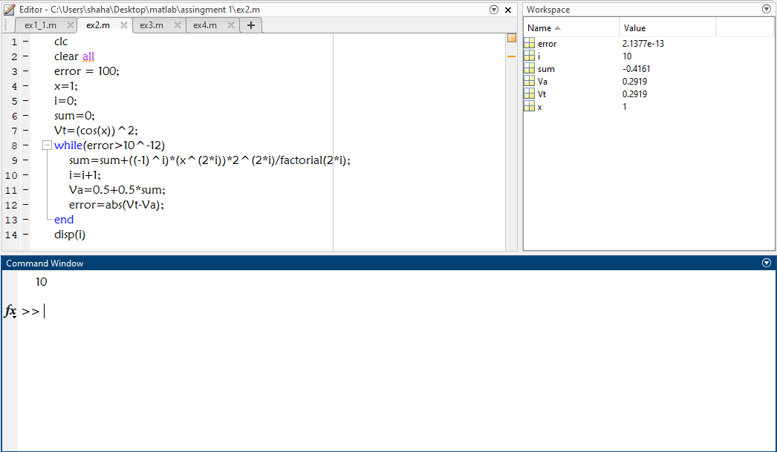

The number of N terms is **10**

In the 2nd part it’s wanted to know the error of this terms. So the program is:

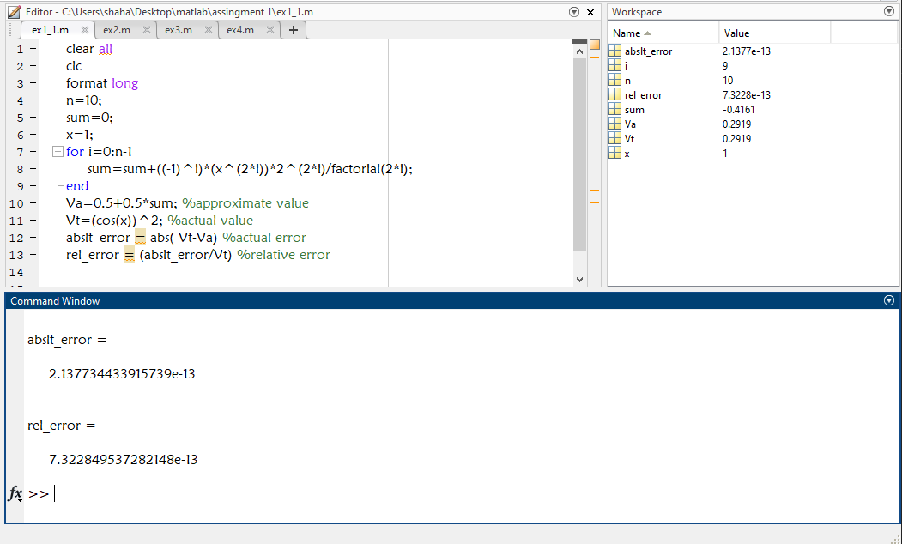

Here

The absolute error is:

**2.137734433915739e-13**

The relative error is**:**

**7.322849537282148e-13**

**3. Find out the maximum error in the series expansion of f(x) = (cos(x)) ^2 using Remainder term for the value of n, obtained in Ques. No. 2, at x=1, which gives the value of f(x) correct to 12 decimal point. And compare it with the absolute error obtained in Ques. No. 2 Discuss why the value of error from Ques. No. 2 and value of maximum error from Ques No.3 is slightly different?**

**Solution:**

In this Que. Its wants to know about maximum error of this series function.

So the program for that:

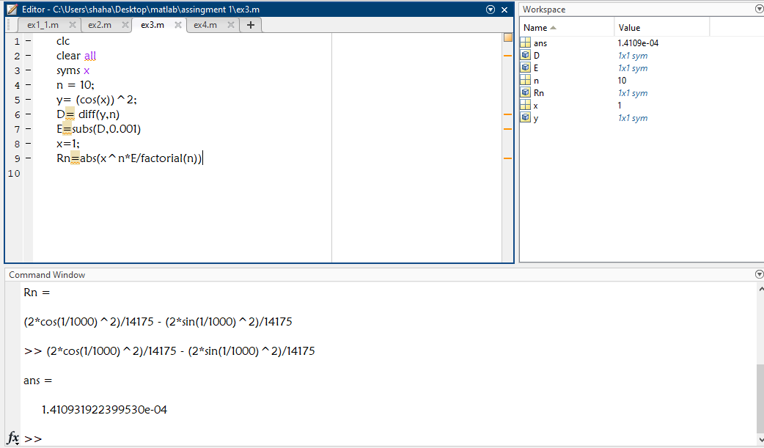

So the maximum error is:

(2*cos (1/1000) ^2)/14175 - (2*sin (1/1000) ^2)/14175

**= 1.410931922399530e-04**.

In the 2nd part of this Que. It’s wanted to know to compare with Que. 2 ans.

The Que. 2 ans is:

**2.137734433915739e-13**

**Yes. It’s slightly different from other**.

**4. Write a program to find out the number of terms n of the series f(x)=(cos(x))^2, without series expansion such that their sum gives the value of f(x) correct to 12 decimal point, when x=1.**

**Solution:**

In this que it’s wanted to know about the number of terms without series expansion. The program is:

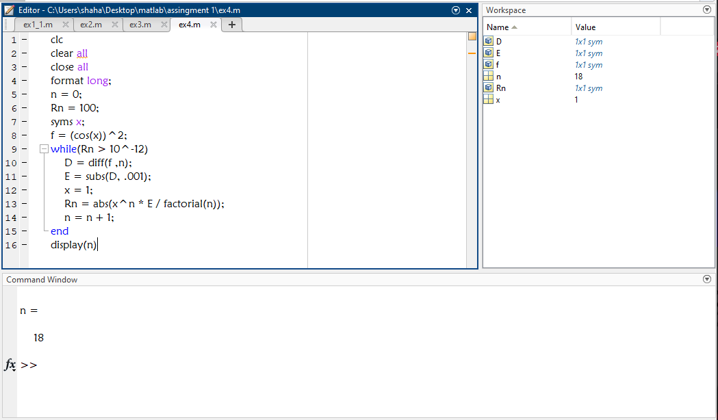

The number of terms of N is: **18**

**5. Comment and discuss on the results of the program.**

1. As it is 1st assignment of using MATLAB. So it was difficult to make sure the perfect answer. But it’s tried to do so.
2. In the 1st problem the number of terms are inversely proportional to error this take much time to understand.
3. In the 2nd problem 10 number of the sum gives the point with 12 decimal point. And it was quite easy
4. In number 3. We solve it by using the methods of maximum error by differentiation.

1. In number 4 its solved by reminder term formula where the number of N terms is : 18
2. Overall it’s tried to do best and also tried to remove the error.